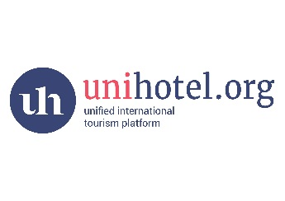
Want to reduce work load for your colleagues and safe money of extra employment?
CONNECT YOUR COMPANY TO UNIHOTEL PLATFORM TODAY and get direct access to all hotels and suppliers .
Trial period is free of charge
Who we are ?
We are a unified international platform for all players in the tourism market – for hotels, tour operators and travel agents around the globe. This platform is created to increase the reach and unify the tourism market worldwide, as well as to standardize information about hotels and assign unique IDs to hotels. The platform also allows increasing the speed of data transfer – photos, description of hotel rooms, restaurants and the entire hotel infrastructure, and speeding up the information and prices exchange, thus enabling the most efficient use of all marketing tools to facilitate your successful sales in the world market.
What`s the benefit to join with us?
- Direct automatically access to all hotels and suppliers with direct agreement and direct payment
- Automatically availability from all hotels and suppliers
- Automatically BTB rates from hotels and suppliers
- Free of charge booking engine
- One click updating all your partners about rates with your own mark up for different markets , availability , stop sale and current news
- One click uploading news to all famous social networks like facebook,twitter,Instagram and ect.
- Saving time and money of sending thousand mails to your partners and keeping extra staff.
- Possibility of using different languages
- Possibility connect all the rates & services with your own mark up to your web site
- Possibility of uploading your own extra services ( round tours,excursions,transfers and ect )
- Automatically generating invoices, confirmation vouchers, accountants reports
- Multicurrency
- Calendar of arrivals and departures
How to join?
- Register your account at unihotel platform
- Upload information about your company
- Invite your travel partners from the globe to Unihotel platform or your own web site
- Upload you own round tours and extra services

How much I have to pay ?
- Registration service is FREE of charge
- Invitation of your partners is FREE of charge
- Uploading all your services & selling through your own network is FREE OF CHARGE
- Monthly fees for connection ( hotels availability and BTB rates) only from 50 $ upwards ( depends of the package and country )

Additional services:
- Booking engine on your own web site under your design with entrance for your partner agencies from 1000 $ upwards
- Common payment gateway with only 0,5% commission
- Translation of your data and information in an language

Save your money and the time!
The platform will work for you even you are sleeping !

Contact with us: +94768986665; +94770495094

